# Task 3: Subqueries and Aggregations.

**Project Steps**

Step 1: Database Setup

1. Table: Students

○ Fields:

■ student_id: Primary Key.

■ name: Name of the student.

■ math_score: Math test score.

■ science_score: Science test score.

■ english_score: English test score.

■ total_score: The sum of all scores for each student (optional if calculated dynamically).

2. Insert sample data with scores for Math, Science, and English for multiple Students

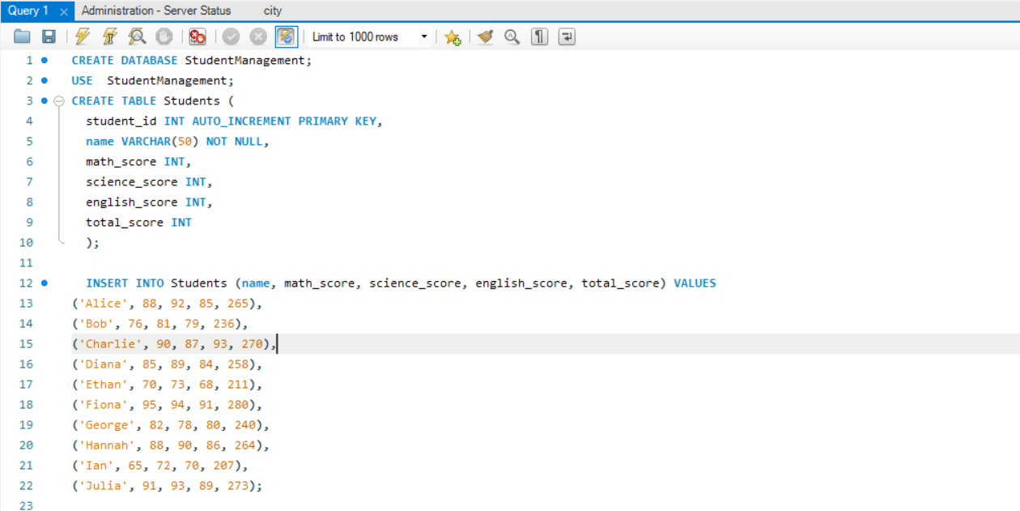

Step 2: Tasks to Perform

Task 1: Identify Top Students by Total Scores

● Use a subquery to calculate the total score (math_score + science_score +

english_score) for each student.

● Use an ORDER BY clause to rank students by their total scores in descending order.

● Limit the results to show only the top students (e.g., top 5).

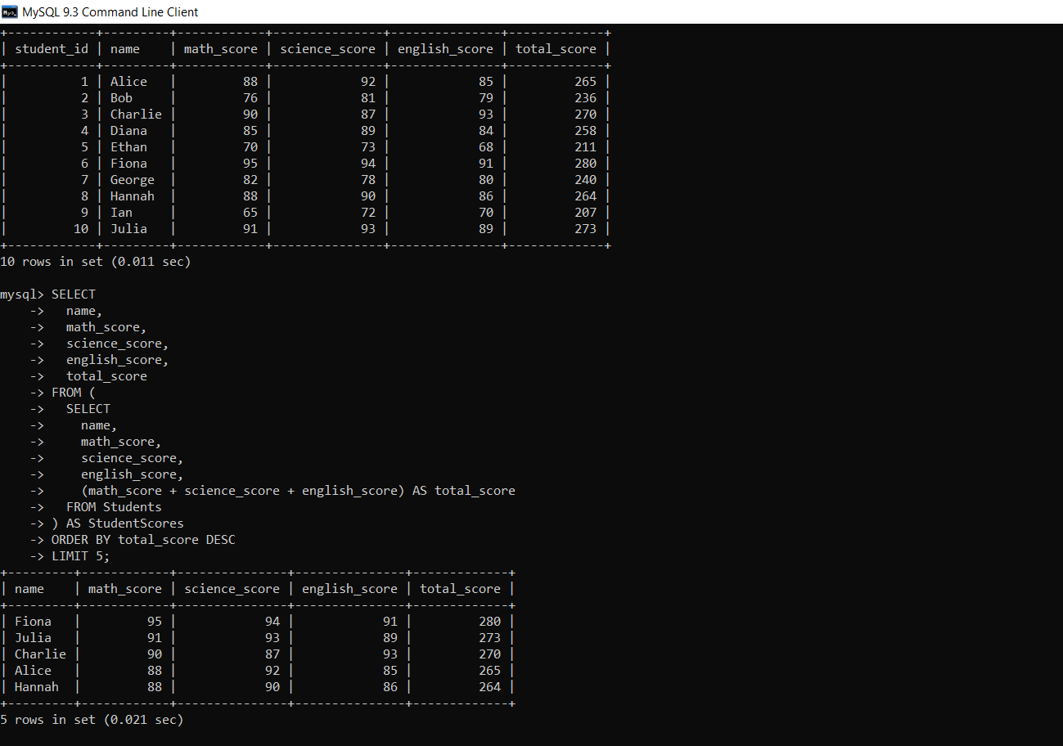

Task 2: Calculate Averages Based on Specific Conditions

● Use subqueries to filter and group data for average calculations:

○ Example 1: Calculate the average score of students who scored above 70 in Math.

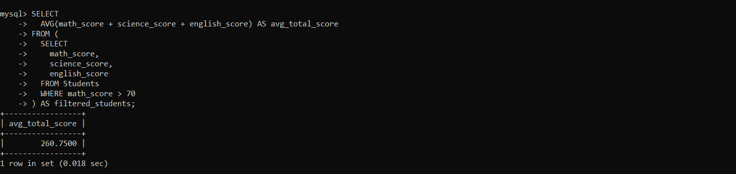

○ Example 2: Calculate the average total score of students grouped by a specific condition, such as a score range (e.g., students scoring 200–250 in total).

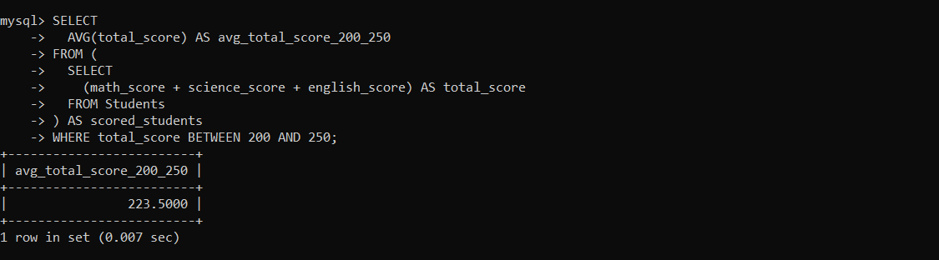

Task 3: Find Second-Highest Math Scores

● Use a subquery to determine the highest Math score and exclude it in a second query to

find the next highest value.

● Example:

○ Use MAX(math_score) in a subquery to find the highest score.

○ Use WHERE math_score < (SELECT MAX(math_score) FROM

Students) to exclude the top score and then use MAX again to find the second

highest score.

